1. **Factorial using Iteration in python**

num = int(input("Enter a number: "))

factorial = 1

if num < 0:

print(" Factorial numbers does not exist")

elif num == 0:

print("The factorial of 0 is 1")

else:

for i in range(1,num + 1):

factorial = factorial*i

print("The factorial of",num,"is",factorial)

**Output :**



**2. Factorial using Recursion in python**

def factorial(n):

if n == 1:

return n

else:

return n*factorial(n-1)

num = int(input("Enter any number: "))

if num < 0:

print("Factorial numbers does not exist")

elif num == 0:

print("The factorial of 0 is 1")

else:

print("The factorial of", num, "is", factorial(num))

**Output :**



**3. Fibonacci series**

num = int(input("Enter the Range Number: "))

First_val = 0

Second_val = 1

for n in range(0, num):

if(n <= 1):

next = n

else:

next = First_val + Second_val

First_val = Second_val

Second_val = next

print(next)

**Output :**

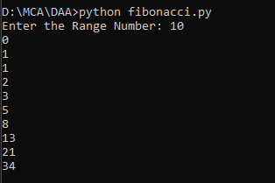

**4. . Fibonacci series using Recursion.**

#include<stdio.h>

int Fibonacci(int);

int main()

{

int n, i = 0, c;

scanf("%d",&n);

printf("Fibonacci series\n");

for ( c = 1 ; c <= n ; c++ )

{

printf("%d\n", Fibonacci(i));

i++;

}

return 0;

}

int Fibonacci(int n)

{

if ( n == 0 )

return 0;

else if ( n == 1 )

return 1;

else

return ( Fibonacci(n-1) + Fibonacci(n-2) );

}

**Output :**

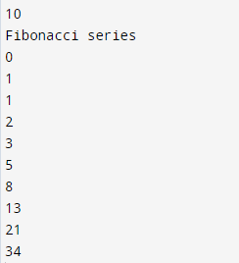

**5. SquareRoot using math.sqrt().**

import math

num = int(input("Enter a number: "))

sqroot= math.sqrt(num)

print("Square Root is :",sqroot)

**Output :**



**6. Multiply two numbers without multiplication operator**

#include<stdio.h>

int main(){

int a,b,i,mul=0;

printf("Enter a and b values :");

scanf("%d%d",&a,&b);

for(i=1;i<=b;i++)

{

mul = mul+a;

}

printf("Multiplication is = %d \n",mul);

return 0;

}

**Output :**

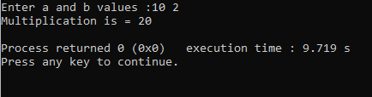

**7. Multiply two numbers without multiplication operator enter the value zero then exit loop.**

#include<stdio.h>

int main(){

int a,b,multi;

printf("Enter the number 1:");

scanf("%d",&a);

printf("Enter the number 2:");

scanf("%d",&b);

while(b != 0)

{

multi += a;

b--;

}

printf("\n Multiplication is: = %d\n", multi);

return 0;

}

**Output :**

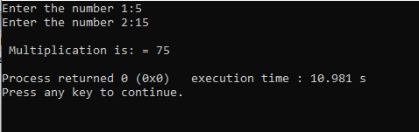

**8. Find Minimum value in Array (static value).**

#include<stdio.h>

#include<conio.h>

void main()

{

int arr[]={9,45,34,67,89};

int length=sizeof(arr[0]);

int min = arr[0];

for(int i=0;i<length;i++){

if(arr[i]<min)

min=arr[i];

}

printf("Smallest Element is :%d\n",min);

}

**Output :**

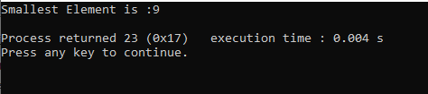

**9. Find Minimum value in Array (user define value)**

#include<stdio.h>

void main()

{

int arr[10],n,min,max;

printf("Enter Size of the Array :");

scanf("%d",&n);

printf("Enter Element in Array :");

for(int i=0;i<n;i++){

scanf("%d",&arr[i]);

}

min=max=arr[0];

for(int i=1;i<n;i++){

if(min>arr[i])

min=arr[i];

if(max<arr[i])

max=arr[i];

}

printf("-----------------");

printf("\n Minimun Element is: %d",min);

printf("\n Maximunm Element is:%d",max);

printf("\n-----------------");

}

**Output :**

